

SCHOOL OF ENGINEERING & TECHNOLOGY

**Department of Computer Science & Engineering**

Jain Global campus

Kanakapura Taluk - 562112  
Ramanagara District, Karnataka, India

CERTIFICATE

This is to certify that the mini-project work on **“**Youth Hostel**”** as part of **16CIC503 – INTRODUCTION TO WEB TECHNOLOGY LAB** is carried out by **Dhiraj Bothra(16BT6CS062)** a bonafide students of Bachelor of Technology in Computer Science and Engineering at the School of Engineering & Technology, Jain University, Bangalore, during the year **2018‑2019.**

|  |  |
| --- | --- |
| **Dr G KOMARASAMY** | **Dr. RAJESH S.L** |
| Associate Professor  Dept. of CS&E,  School of Engineering & Technology,  Jain University | Head of the Department, Dept. of CS&E,  School of Engineering & Technology,  Jain University |

<

DECLARATION

I, Dhiraj Bothra (16BT6CS062) student of fifth semester B.Tech in Computer Science & Engineering, at School of Engineering & Technology, Jain University. We hereby declare that the mini-project titled “Youth Hostel” has been carried out by me and submitted in the partial fulfilment for the course 16CIC503 – INTRODUCTION TO WEB TECHNOLOGY LAB as part of my degree in Bachelor of Technology in Computer Science & Engineering during the academic year 2018‑2019.

|  |  |
| --- | --- |
|  | **Signature:** |
| **Name: Dhiraj Bothra**  **USN : 16BT6CS062** |  |
|  |  |
|  |  |
|  |  |
| **Place : Bangalore**  **Date :27/11/2018** |  |

**ACKNOWLEDGEMENT**

It is a great pleasure for me to acknowledge the assistance and support of a large number of individuals who have been responsible for the successful completion of this mini-project work.

We would like to thank **Dr. Hariprasad S A, Director, School of Engineering & Technology, Jain University** for his constant encouragement and expert advice.

It is a matter of immense pleasure to express our sincere thanks to **Prof. Rajesh S.L, Head of the department, Computer Science & Engineering, Jain University**, for providing right academic guidance that made our task possible.

We would like to thank my guide **Prof. G Komarasamy, Associate Professor, Dept. of Computer Science & Engineering, Jain University**, for sparing his valuable time to extend help in the project work.

I would like to thank one and all who directly or indirectly helped us in completing the project work successfully.

Signature of Student

ABSTRACT

**This page will contain a concise and brief summary of the project. The entire abstract should be covered in single paragraph not extending more than 250 words.**

**TABLE OF CONTENTS**

|  |  |
| --- | --- |
| **Contents** | **Page No** |
| **1**. Abstract | 01 |
| **2**. Introduction | 01 |
| **3**. Objectives | 01 |
| **4**. Methodogy | 02-04 |
| 4. HTML |  |
| 4.2 CSS |  |
| 4.3 Javascript |  |
| 4.4 jQuery |  |
| 4.5 PHP and Mysql Database |  |
| 4.6 Proposed System |  |
| **5**. Program | 05-15 |
| 5.1 index.html |  |
| 5.2 about.html |  |
| 5.3 services.html |  |
| 5.4 gallery.html |  |
| 5.5 contact.html |  |
| **6.** Output | 16-20 |
| 6.1 Home Page |  |
| 6.2 About Page |  |
| 6.3 Service page |  |
| 6.4 Gallery Page |  |
| 6.5 Contact Page |  |
| **7.** Innovation and Contribution to the Project | 21 |

**SYNOPSIS**

**PROJECT TITLE:**

**Website for YOUTH HOSTEL**

**Using**

**HTML, PHP and MySQL**

**1.ABSTRACT**

This project concentrates on providing the homes at affordable rates. To become a center of safe, affordable and clean accommodation for young people during their travel

This project provides opportunity of travel at a nominal cost far more easily available for youth. To encourage youth travelling in India and education & understanding through personal experience.

**2.INTRODUCTION**

YHAI is an associate member of the Hosteling International (Welwyn Garden City, England, U.K.), which has the world’s largest network of 4500+ Youth Hostels in 90 countries across the globe, and, world’s largest **youth membership**organization. Our hostels follow stringent Hygiene and Quality standards, and they are the places where people of different backgrounds, class, religion, age groups, come together and enjoy. They get to know each other, make friends and share knowledge. Our Hostels are the places to fall in friendship with likeminded people.

Youth Hosteling as a movement has not taken long to establish in the world. During the course of the last almost eighty years, it has spread from country to country and spanned all the five continents.

**3.OBJECTIVES**

The objectives involving in this problem are:

* To aim at providing comfortable, hygienic accommodations with assured quality standards at affordable rates
* To provide a **real hostel**experience to all those who want to travel to explore the unique world around them.
* Aim at achieving a well designed home which enables easy movements.

**4.METHODOLOGY**

**4.1 HTML**

Hypertext Markup Language is the standard markup language for creating web pages and web applications. With cascading style sheets and JavaScript, it forms a triad of cornerstone technologies for the world wide web. Web browsers receive HTML documents from a web server or from local storage and render the documents into multimedia web pages.HTML describes the structure of a web page semantically and originally included cues for the appearance of the document.

**4.2 CSS**

CSS is a language that describes the style of an HTML document.CSS describes how HTML elements should be displayed. There are three ways to insert CSS.They are:

* External style sheet-With an external style sheet, you can change the look of an entire website by changing just one file.
* Inline style- An inline style may be used to apply a unique style for a single element.
* Internal style sheet

**4.3 JavaScript**

JavaScript is a client-side as well as server side scripting language that can be inserted into HTML pages and is understood by web browsers. JavaScript is an object-based scripting language which is light weight and cross-platform. JavaScript is not a compiled language but it is a translated language. The JavaScript Translator is responsible for translating the JavaScript code for the web browser.

**4.4 jQuery**

**LightBox** Plugin is simple, elegant, unobtrusive, no need extra markup and is used to overlay images on the current page through the power and flexibility of **jQuery**´s selector. **light Box** is a plugin for **jQuery** and it was inspired in **Lightbox** JS.

**ResponsiveSlides.js** is a tiny jQuery plugin that automatically creates responsive slider using images inside a container.

**4.5 php and MySQL database**

With PHP, you can connect to and manipulate databases.

MySQL is the most popular database system used with PHP.

Before we can access data in the MySQL database, we need to be able to **connect to the server:**

<?php  
$servername= "localhost";  
$username= "username";  
$password= "password";  
//Create-connection  
$conn = new mysqli($servername, $username, $password);

?>

**4.6Proposed System**

|  |  |
| --- | --- |
| **Hardware Requirements** | * AMD Pentium Processor * 4GB RAM |
| **Software Requirements** | * Windows 32/64 bit operating System |
| **Platform** | * Windows 32/64 bit operating System |
| **Programming Language/Tools** | HTML,CSS,JavaScript |

**5.PROGRAM:**

**5.1 CODE FOR INDEX:**

<!DOCTYPE HTML>

<html>

<head>

<title>Hostel Website | Home</title>

<link href="css/style.css" rel="stylesheet" type="text/css"

media="all" />

<link href='http://fonts.googleapis.com/css?family=PT+Sans+Narrow'

rel='stylesheet' type='text/css'>

<link rel="stylesheet" href="css/responsiveslides.css">

<script src="http://ajax.googleapis.com/ajax/libs/jquery/1.8.3/jquery.min.js">

</script>

<script src="js/responsiveslides.min.js"></script>

</head>

<body>

<div class="header">

<div class="wrap">

<div class="header-top">

<div class="logo">

<a href="index.html"><img src="images/logo2.png" title="logo"

height="100" width="400"/></a>

</div>

<div class="contact-info">

<p class="phone">Call us : <a href="#">980XXXXXXX</a></p>

</div>

<div class="clear"> </div>

</div>

</div>

<div class="header-top-nav">

<div class="wrap">

<ul>

<li class="active"><a href="index.html">Home</a></li>

<li><a href="about.html">About</a></li>

<li><a href="services.html">Services</a></li>

<li><a href="gallery.html">Gallery</a></li>

<li><a href="contact.html">Contact</a></li>

<div class="clear"> </div>

</ul>

</div>

</div>

</div>

<div class="clear"> </div>

<li><img src="images/slider2.jpg" alt="" height="300" width=100% ></li>

<div class="content">

<div class="quit">

<p><span class="start">ARRIVE AS GUEST LEAVE AS FRIEND </span>

<span class="end"></span></p>

</div>

<div class="content-grids">

<div class="wrap">

<div class="content-grid">

<div class="content-grid-pic">

<a href="#"><img src="images/icon1.png"

title="image-name" /></a>

</div>

<div class="content-grid-info">

<h3>Best food Ever</h3>

<p3>We always believe that the route to your heart is

through your stomach and to reach your heart.</p3>

</div>

<div class="clear"> </div>

</div>

<div class="content-grid">

<div class="content-grid-pic">

<a href="#"><img src="images/icon2.png"

title="image-name" /></a>

</div>

<div class="content-grid-info">

<h3>24x7 phone support</h3>

<p>Kinsta offers 24/7 support via our online messaging system,

which is always one click away in your dashboard.</p>

</div>

<div class="clear"> </div>

</div>

<div class="content-grid">

<div class="content-grid-pic">

<a href="#"><img src="images/iocn3.png" title="image-name"/></a>

</div>

<div class="content-grid-info">

<h3>Best Room Services</h3>

<p>Enabling guests to choose menu items for delivery to their

hotel room for consumption there, served by staff.</p>

</div>

<div class="clear"> </div>

</div>

<div class="clear"> </div>

</div>

</div>

<div class="clear"> </div>

<div class="content-box">

<div class="wrap">

<div class="content-box-left">

<div class="content-box-left-topgrid">

<h3>welcome to our Hotel</h3>

<p>Feel Like Home .</p>

<p>We aim at providing comfortable, hygienic accommodations with

assured quality standards at affordable rates, as we believe in

providing a real hostel experience to all those who want to travel

to explore the unique world around them.</p>

<span>For more information about our Hotel, Call 980XXXXXXX</span>

</div>

<div class="content-box-left-bootomgrids">

<div class="content-box-left-bootomgrid">

<h3>Single Rooms</h3>

<p> Provided with single bed.</p>

<a href="#"><img src="images/slider1.jpg" title="image-name"/></a>

</div>

<div class="content-box-left-bootomgrid">

<h3>Deluxe Rooms</h3>

<p>Provided with double bed.</p>

<a href="#"><img src="images/slider2.jpg" title="image-name"/></a>

</div>

<div class="content-box-left-bootomgrid lastgrid">

<h3>Dormitory</h3>

<p>Provided with 20 bed.</p>

<a href="#"><img src="images/slider3.jpg" title="image-name"/></a>

</div>

<div class="clear"> </div>

</div>

<div class="clear"> </div>

</div>

<div class="content-box-right">

<div class="content-box-right-topgrid">

<h3>To days Specials</h3>

<a href="#"><img src="images/slider1.jpg" title="imnage-name"/></a>

<h4>Super Discount Offer</h4>

<p>For Students.</p>

</div>

<div class="content-box-right-bottomgrid">

</div>

</div>

<div class="clear"> </div>

</div>

<div class="clear"> </div>

<div class="boxs">

<div class="wrap">

<div class="box">

</div>

<div class="clear"> </div>

</div>

</div>

</div>

</div>

</body>

</html>

**5.2 CODE FOR ABOUT:**

<!DOCTYPE HTML>

<html>

<head>

<title>YOUTH HOSTEL | About</title>

<link href="css/style.css" rel="stylesheet" type="text/css" media="all" />

<link href='http://fonts.googleapis.com/css?family=PT+Sans+Narrow'

rel='stylesheet' type='text/css'>

</head>

<body>

<div class="header">

<div class="wrap">

<div class="header-top">

<div class="logo">

<a href="index.html"><img src="images/logo2.png" title="logo" height="100" width="400"/></a>

</div>

<div class="contact-info">

<p class="phone">Call us : <a href="#">980XXXXXXXX</a></p>

</div>

<div class="clear"> </div>

</div>

</div>

<div class="header-top-nav">

<div class="wrap">

<ul>

<li><a href="index.html">Home</a></li>

<li class="active"><a href="about.html">About</a></li>

<li><a href="services.html">Services</a></li>

<li><a href="gallery.html">Gallery</a></li>

<li><a href="contact.html">Contact</a></li>

<div class="clear"> </div>

</ul>

</div>

</div>

</div>

<!---End-header--->

<div class="clear"> </div>

<!---start-content----->

<div class="content">

<div class="wrap">

<!---start-about---->

<div class="about">

<div class="about-grids">

<div class="about-grid">

<h3>About Our Hostel</h3>

<a href="#"><img src="images/slider1.jpg" title="about"></a>

<p> Feel like home.</p>

<a class="button1" href="http://www.yhmysore.com/about_us.html">

Read More</a>

</div>

<div class="about-grid center-grid1">

<h3>WHY CHOOSE US?</h3>

<p>Ease in cost.It is a place for forming friendship, recreation

and informal education.It provides young people on their

educational excursions inexpensive hostelling facilities in the

form of dormitories –separate for ladies and gents, a dining hall

with self-service, a common room or lounge.</p>

</div>

<div class="about-grid last-grid">

<h3>Our Hostel's Staff Info.</h3>

<div class="about-team">

<div class="client">

<div class="about-team-left">

<a href="#"><img src="images/c1.jpg"

title="client-name"></a>

</div>

<div class="about-team-right">

<p> Dhiraj Bothra</p>

</div>

<div class="clear"> </div>

</div>

<div class="client">

<div class="about-team-left">

<a href="#"><img src="images/c2.jpg"

title="client-name"></a>

</div>

<div class="about-team-right">

<p>Dheeren Jain</p>

</div>

<div class="clear"> </div>

</div>

</div>

</div>

<div class="clear"> </div>

</div>

</div>

</div>

</div>

</div>

</div>

</div>

</body>

</html>

**5.3CODE FOR SERVICES:**

<!DOCTYPE HTML>

<html>

<head>

<title>Hotel Website | Services</title>

<link href="css/style.css" rel="stylesheet" type="text/css" media="all" />

<link href='http://fonts.googleapis.com/css?family=PT+Sans+Narrow'

rel='stylesheet' type='text/css'>

</head>

<body>

<div class="header">

<div class="wrap">

<div class="header-top">

<div class="logo">

<a href="index.html"><img src="images/logo2.png" title="logo"

height="100" width="400"/></a>

</div>

<div class="contact-info">

<p class="phone">Call us : <a href="#">980XXXXXXX</a></p>

</div>

<div class="clear"> </div>

</div>

</div>

<div class="header-top-nav">

<div class="wrap">

<ul>

<li><a href="index.html">Home</a></li>

<li><a href="about.html">About</a></li>

<li class="active"><a href="services.html">Services</a></li>

<li><a href="gallery.html">Gallery</a></li>

<li><a href="contact.html">Contact</a></li>

<div class="clear"> </div>

</ul>

</div>

</div>

</div>

<div class="clear"> </div>

<div class="content">

<div class="wrap">

<div class="services">

<div class="service-content">

<h3>Our Hotel Services</h3>

<ul>

<li><span>1.</span></li>

<li><p><a href="#">Rest Room</a> Put your luggage and roam around the city.

</p></li>

<div class="clear"> </div>

</ul>

<ul>

<li><span>2</span></li>

<li><p><a href="#">Parks</a> You can play different games and chill.

</p></li>

<div class="clear"> </div>

</ul>

<ul>

<li><span>3.</span></li>

<li><p><a href="#">Canteen</a> We are sure your taste buds will surely

bless you for this visit. </p></li>

<div class="clear"> </div>

</ul>

<ul>

<li><span>4.</span></li>

<li><p><a href="#">Conference Hall</a>Ideally suited for all banquets

and functions.</p></li>

<div class="clear"> </div>

</ul>

<ul>

<li><span>5.</span></li>

<li><p><a href="#">Currency Exchange</a>Provides

reliable foreign currency exchange services.</p></li>

<div class="clear"> </div>

</ul>

<ul>

<li><span>6.</span></li>

<li><p><a href="#">Room Services</a> Equipment used

by professionals for home deep cleaning service. </p></li>

<div class="clear"> </div>

</ul>

</div>

<div class="services-sidebar">

<h3>WE PROVIDE</h3>

<ul>

<li><a href="#">24-hour front desk</a></li>

<li><a href="#">Parking</a></li>

<li><a href="#">Car Rental</a></li>

<li><a href="#">ATM</a></li>

<li><a href="#">Emercency Number</a></li>

</ul>

</div>

<div class="clear"> </div>

</div>

</div>

</div>

</div>

</div>

</body>

</html>

**5.4 CODE FOR GALLERY:**

<!DOCTYPE HTML>

<html>

<head>

<title>Hotel Website | Gallery</title>

<link href="css/style.css" rel="stylesheet" type="text/css" media="all" />

<link href='http://fonts.googleapis.com/css?family=PT+Sans+Narrow'

rel='stylesheet' type='text/css'>

<script src="http://ajax.googleapis.com/ajax/libs/jquery/1.8.3/jquery.min.js">

</script>

</head>

<body>

<div class="header">

<div class="wrap">

<div class="header-top">

<div class="logo">

<a href="index.html"><img src="images/logo2.png" title="logo"

height="100" width="400"/></a>

</div>

<div class="contact-info">

<p class="phone">Call us : <a href="#">980XXXXXXX</a></p>

</div>

<div class="clear"> </div>

</div>

</div>

<div class="header-top-nav">

<div class="wrap">

<ul>

<li><a href="index.html">Home</a></li>

<li><a href="about.html">About</a></li>

<li><a href="services.html">Services</a></li>

<li class="active"><a href="gallery.html">Gallery</a></li>

<li><a href="contact.html">Contact</a></li>

<div class="clear"> </div>

</ul>

</div>

</div>

</div>

<div class="clear"> </div>

<div class="content">

<div class="wrap">

<div class="gallerys">

<h3>gallery</h3>

<div class="gallery-grids">

<div class="gallery-grid">

<a href="images/counter.jpg"><img src="images/counter.jpg"></a>

<h4>Reception Counter</h4>

</div>

<div class="gallery-grid grid2">

<a href="images/dinning.jpg"><img src="images/dinning.jpg"></a>

<h4>Dinning Hall</h4>

</div>

<div class="gallery-grid">

<a href="images/sketch.jpg"><img src="images/sketch.jpg"></a>

<h4>An Artist's View</h4>

</div>

<div class="clear"> </div>

</div>

<div class="clear"> </div>

<div class="gallery-grids">

<div class="gallery-grid">

<a href="images/garden.jpg"><img src="images/garden.jpg"></a>

<h4>Inside view of garden</h4>

</div>

<div class="gallery-grid grid2">

<a href="images/tt.jpg"><img src="images/tt.jpg"></a>

<h4>Table Tennis</h4>

</div>

<div class="gallery-grid">

<a href="images/bad.jpg"><img src="images/bad.jpg"></a>

<h4>Badminton Court</h4>

</div>

</div>

<script type="text/javascript" src="js/jquery.lightbox.js"></script>

<link rel="stylesheet" type="text/css" href="css/lightbox.css"

media="screen">

<script type="text/javascript">

$(function() {

$('.gallery-grid a').lightBox();

});

</script>

<div class="clear"> </div>

<div class="projects-bottom-paination">

<ul>

<li class="active"><a>1</a></li>

</ul>

</div>

</div>

</div>

</div>

</div>

</body>

</html>

**5.5 CODE FOR CONTACT:**

<!DOCTYPE HTML>

<html>

<head>

<title>YOUTH Hostel Website | Gallery </title>

<link href="css/style.css" rel="stylesheet" type="text/css"

media="all" />

<link href='http://fonts.googleapis.com/css?family=PT+Sans+Narrow'

rel='stylesheet' type='text/css'>

</head>

<body>

<div class="header">

<div class="wrap">

<div class="header-top">

<div class="logo">

<a href="index.html"><img src="images/logo2.png"

title="logo" height="100" width="400"/></a>

</div>

<div class="contact-info">

<p class="phone">Call us : <a href="#">980XXXXXXX</a></p>

</div>

<div class="clear"> </div>

</div>

</div>

<div class="header-top-nav">

<div class="wrap">

<ul>

<li><a href="index.html">Home</a></li>

<li><a href="about.html">About</a></li>

<li><a href="services.html">Services</a></li>

<li><a href="gallery.html">Gallery</a></li>

<li class="active"><a href="contact.html">Contact</a></li>

<div class="clear"> </div>

</ul>

</div>

</div>

</div>

<div class="clear"> </div>

<div class="content">

<div class="wrap">

<div class="contact">

<div class="section group">

<div class="col span_1_of_3">

<div class="contact_info">

</div>

<div class="company_address">

<h3>Hostel Information :</h3>

<p>Gangothri Layout, Saraswathipuram,</p>

<p> Karnataka, IND. </p>

<p>Phone:(061) 5XXXXX</p>

<p>Fax: (000) 00000000</p>

<p>Follow us on: <span>Facebook</span>, <span>Twitter</span></p>

</div>

</div>

<div class="col span_2_of_3">

<div class="contact-form">

<h3>Contact Us</h3>

<form method="post" action="contact-post.html">

<div>

<span><label>FULL NAME</label></span>

<span><input name="userName" type="text"

class="textbox"></span>

</div>

<div>

<span><label>E-MAIL ID</label></span>

<span><input name="userEmail" type="text"

class="textbox"></span>

</div>

<div>

<span><label>MOBILE NUMBER</label></span>

<span><input name="userPhone" type="text"

class="textbox"></span>

</div>

<div>

<span><label>SUBJECT</label></span>

<span><textarea name="userMsg"> </textarea></span>

</div>

<div>

<span><input type="submit" value="Submit"></span>

</div>

</form>

</div>

</div>

</div>

</div>

</div>

</div>

</div>

</div>

</body>

</html>

**6.OUTPUT:**

**Home Page:**

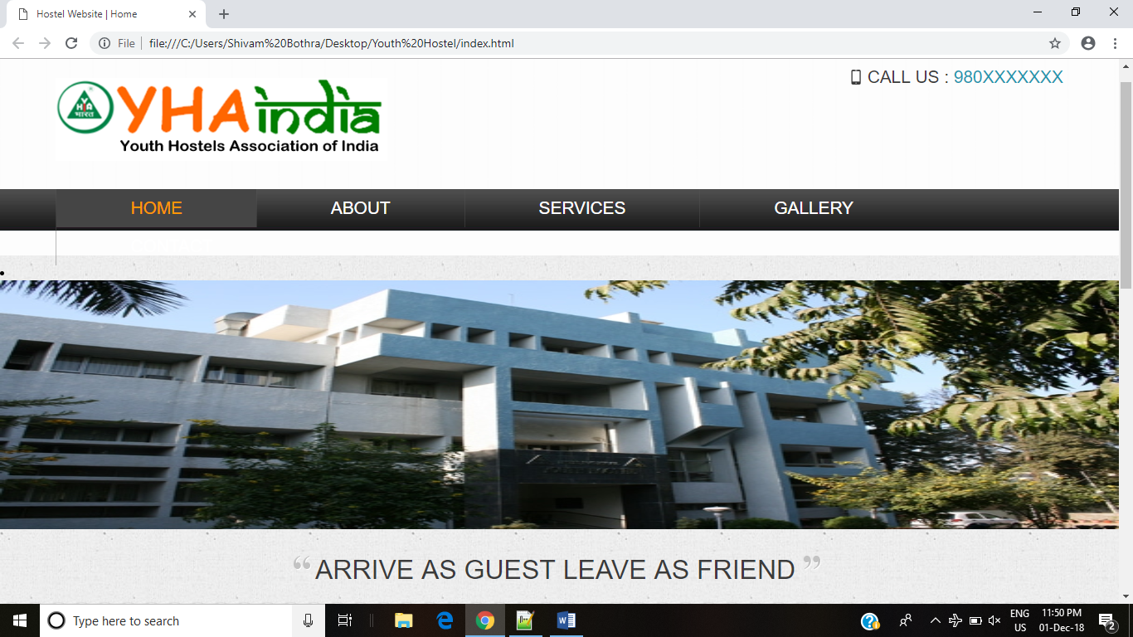

**Information Page:**

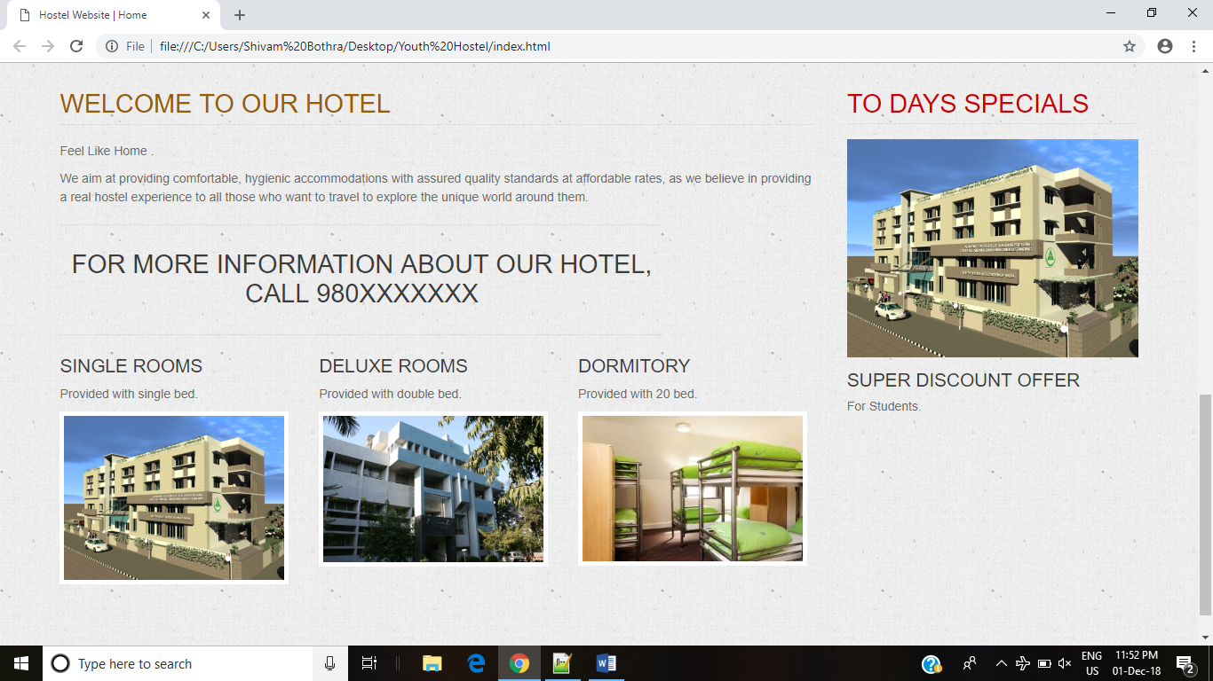

**About Page:**

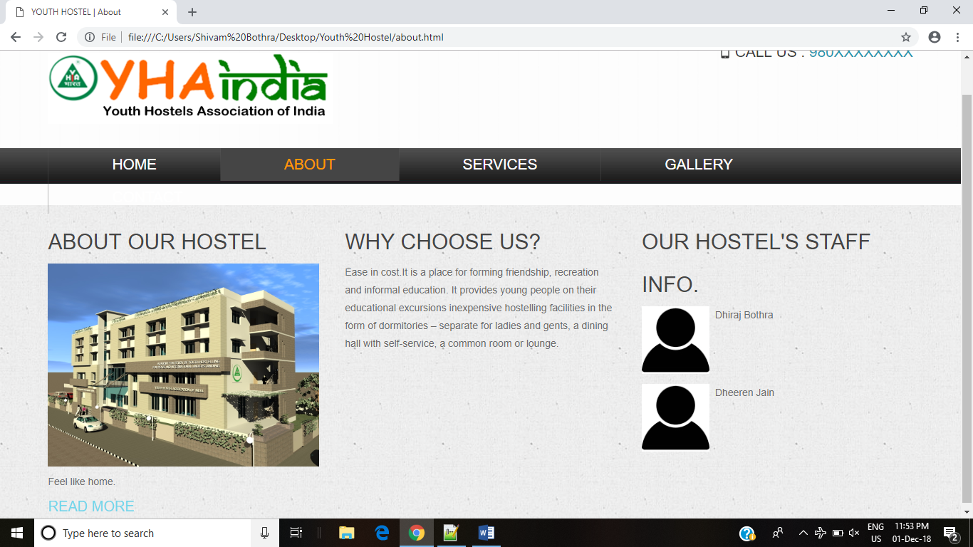

**Service Page:**

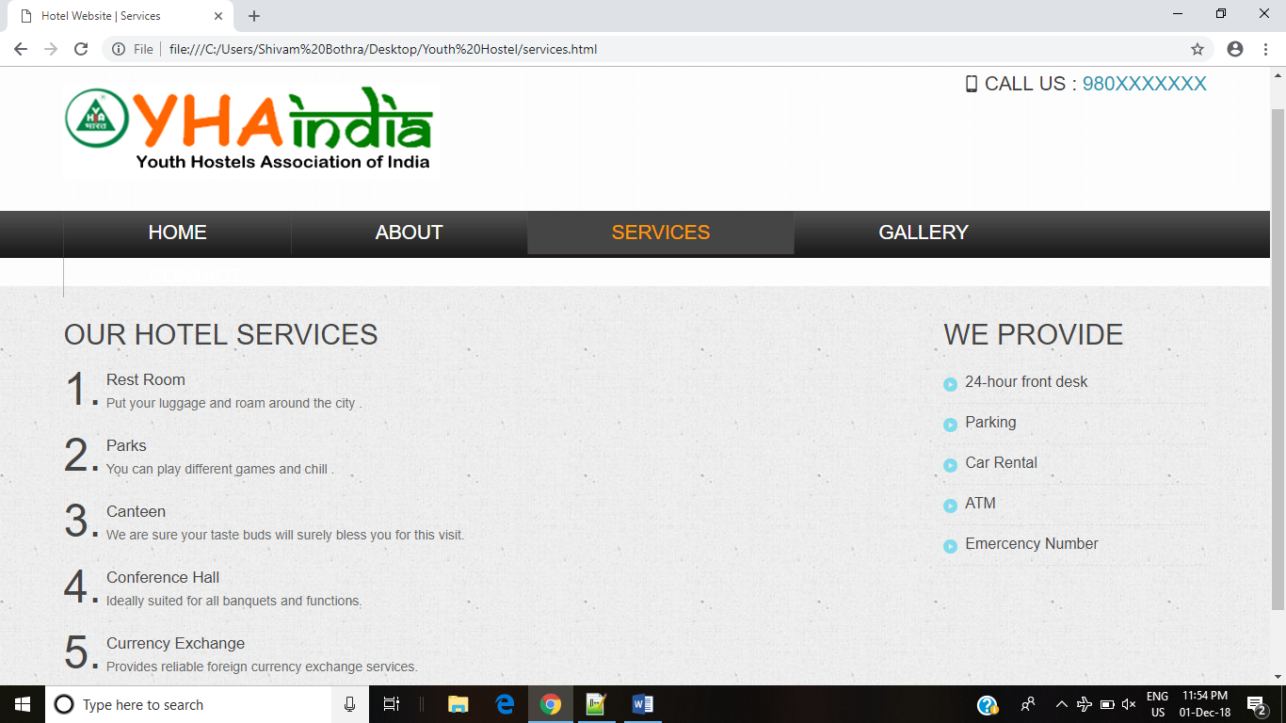

**Gallery Page:**

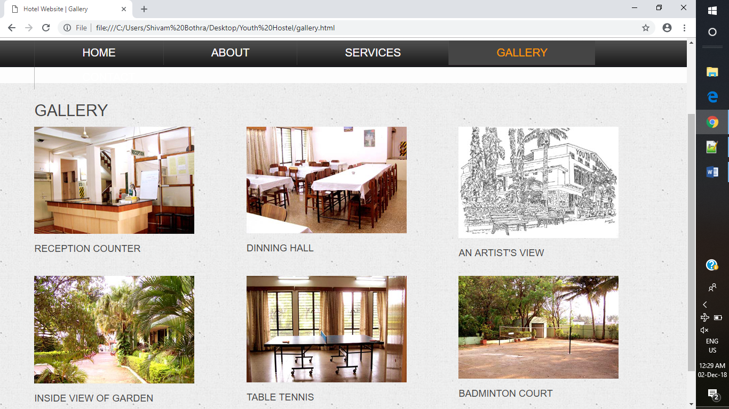

**Contact Page:**

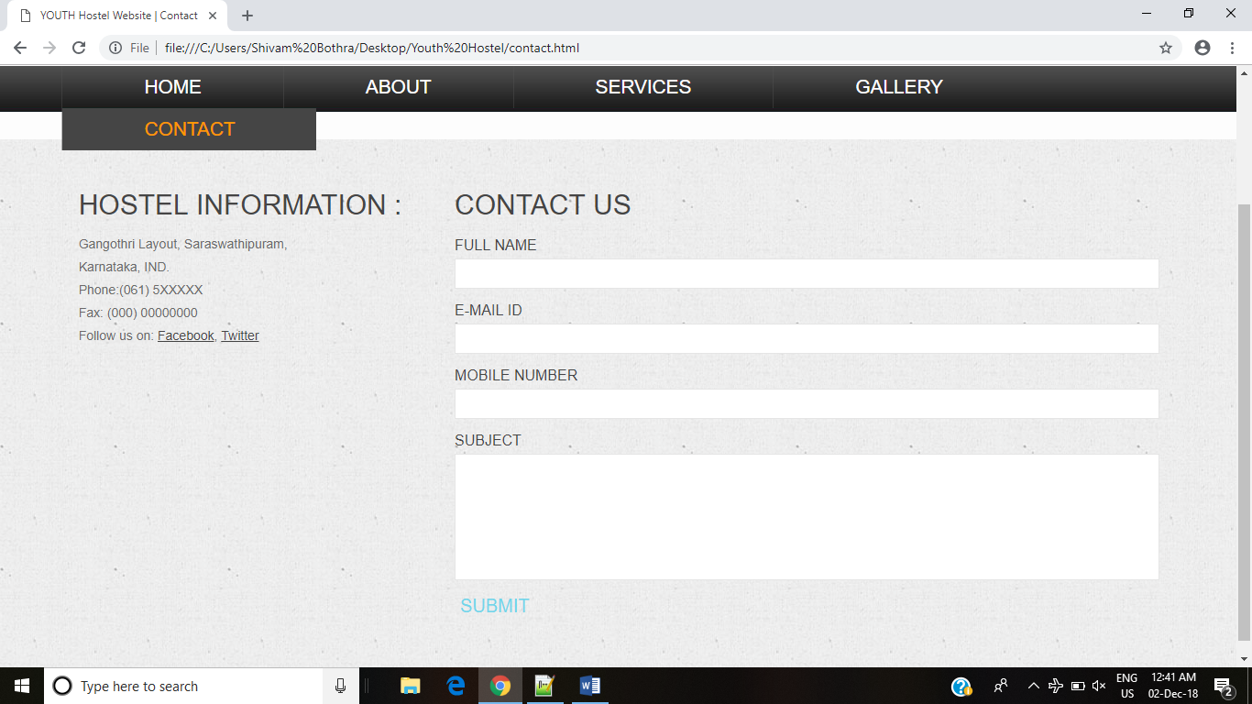

**7.INNOVATION AND CONTRIBUTION TO THE PROJECT:**

* Enhances providing comfortable, hygienic accommodations with assured quality standards at affordable rates.
* Formulate design which is practical ,aesthetic and conductive to intended purposes such raising productivity,selling merchandise or improvinglife style.
* This project as opposed to real world websites which uses php and angular-js etc., is building entirely on html, CSS and JavaScript, this has been done bring forth the importance of html.

**Student Signature**

**Name: DHIRAJ BOTHRA**

**USN No: 16BT6CS062**